# Homework: CSS Layout

This document defines homework assignments from the [“Web Fundamentals (HTML & CSS)“ Course @ SoftUni](https://softuni.bg/courses/web-fundamentals/). Please submit as homework a single zip / 7z archive holding the source code of all below described problems.

## Website Header

Create a Web page header like the picture below (**100% accuracy is required**). Use list for the menu. Use text input field and button for the search. Link the SoftUni logo with [https://softuni.bg](https://softuni.bg/). The menu buttons must work (open some URL). The menu must have dropdown functionality on mouse hover.



<!DOCTYPE html>

<html>

<head>

<link href="style.css" rel="stylesheet" />

<link rel="stylesheet" href="reset.css"/>

<title>Website Header</title>

<meta charset = "utf-8" />

</head>

<body>

<div id="wrapper">

<div id="logo">

<a href = "http://softuni.bg">

<img src = "resources/logo.png" alt = "softuni" title = "SoftUni"/>

</a>

</div>

<div id="container">

<div id="upper-menu">

<div id="notifications">

<span id="zero">0</span>

<img src="resources/notifications.jpg" alt="notifications" title="Notifications" id="notif-pic"/>

</div>

<div id="user">

<span id="user">USER &blacktriangledown;</span>

<ul id="user-menu">

<li><a href="https://softuni.bg/users/profile/show">Profile</a></li>

<li><a href="https://softuni.bg/users/teamwork/list">Teamwork</a></li>

<li><a href="https://softuni.bg/certificates/certificates">Certificates</a></li>

</ul>

</div>

<div id="search">

<form method="get" action="#">

<input type="search" name="search" placeholder="Search..." />

<input type="image" src="resources/search.png" />

</form>

</div>

</div>

<div id="menu">

<nav>

<ul id="main-menu">

<li><a href="http://softuni.bg/news">NEWS</a></li>

<li id="about">ABOUT THE UNIVERSITY &blacktriangledown;

<ul class="drop-down" id="about-menu">

<li><a href="https://softuni.bg/about">About SoftUni</a></li>

<li><a href="https://softuni.bg/curriculum">Curriculum</a></li>

<li><a href="https://softuni.bg/plan">Plan</a></li>

</ul>

</li>

<li id="training">TRAINING COURSES &blacktriangledown;

<ul class="drop-down" id="courses">

<li><a href="https://softuni.bg/trainings/courses/list">Courses</a></li>

<li><a href="https://softuni.bg/trainings/coursesinstances/details/1058">C# Basics September</a></li>

<li><a href="https://softuni.bg/trainings/coursesinstances/details/1056">Java Basics September</a></li>

<li><a href="https://softuni.bg/trainings/coursesinstances/details/1065">Web Fundamentals (HTML + CSS) September</a></li>

<li class="menu-section"><a href="https://softuni.bg/trainings/seminars/list">Seminars</a></li>

<li><a href="https://softuni.bg/trainings/seminars/details/1067">Advanced CSS</a></li>

</ul>

</li>

<li><a href="http://softuni.bg/companies">FOR COMPANIES</a></li>

<li><a href="http://softuni.bg/forum">FORUM</a></li>

<li><a href="http://softuni.bg/CONTACTS">CONTACTS</a></li>

</ul>

</nav>

</div>

</div>

</div>

</body>

## Website Footer

Create a Web page footer like the picture below (**100% accuracy is required**). Use sections for each footer area. Use lists for the menus. The menu buttons must work (open some URL). Embed the Facebook like box using the official FB developer's site: <https://developers.facebook.com/docs/plugins/like-box-for-pages>.

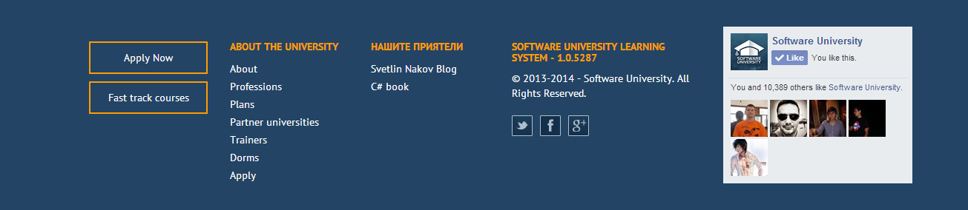

<!DOCTYPE html>

<html>

<head>

<link rel="stylesheet" href="reset.css"/>

<link href="style.css" rel="stylesheet" />

<title>Website Footer</title>

<meta charset = "utf-8" />

</head>

<body>

<script>

(function (d, s, id) {

var js, fjs = d.getElementsByTagName(s)[0];

if (d.getElementById(id)) return;

js = d.createElement(s); js.id = id;

js.src = "//connect.facebook.net/bg_BG/sdk.js#xfbml=1&version=v2.0";

fjs.parentNode.insertBefore(js, fjs);

}(document, 'script', 'facebook-jssdk'));

</script>

<div id="wrapper">

<section id="submit">

<input type="submit" value="Apply Now"/>

<input type="submit" value="Fast track courses" />

</section>

<section id="about">

<header>about the university</header>

<ul>

<li><a href="http://softuni.bg/about">About</a></li>

<li><a href="https://softuni.bg/diplomas-and-certificates">Professions</a></li>

<li><a href="https://softuni.bg/curriculum">Plans</a></li>

<li><a href="https://softuni.bg/university-partners">Partner universities</a></li>

<li><a href="https://softuni.bg/trainers">Trainers</a></li>

<li><a href="http://judge.softuni.bg">Dorms</a></li>

<li><a href="https://softuni.bg/apply">Apply</a></li>

</ul>

</section>

<section id="friends">

<header>нашите приятели</header>

<ul>

<li><a href="http://nakov.com">Svetlin Nakov Blog</a></li>

<li><a href="http://nakov.com">C# book</a></li>

</ul>

</section>

<section id="social-media">

<header>software university learning system - 1.0.5287</header>

<p>&copy; 2013-2014 - Software University. All Rights Reserved.</p>

<button id="twitter">

<a href="http://twitter.com">

<img src="resources/twitter.png"/>

</a>

</button>

<button id="facebook">

<a href="http://facebook.com">

<img src="resources/facebook.png"/>

</a>

</button>

<button id="google">

<a href="http://google.com">

<img src="resources/googleplus.png"/>

</a>

</button>

</section>

<section id = "facebook">

<div class = "fb-like-box"

data-href = "https://www.facebook.com/SoftwareUniversity"

data-height = "260"

data-colorscheme = "light"

data-show-faces = "true"

data-header = "false"

data-stream = "false"

data-show-border = "true">

</div>

</section>

</div>

</body>

</html>

## The SoftUni News

Create a HTML page like the image below. **100% accuracy is required.** Use **external CSS** file for the styles. Use floating articles for the news and list for the paging bar.

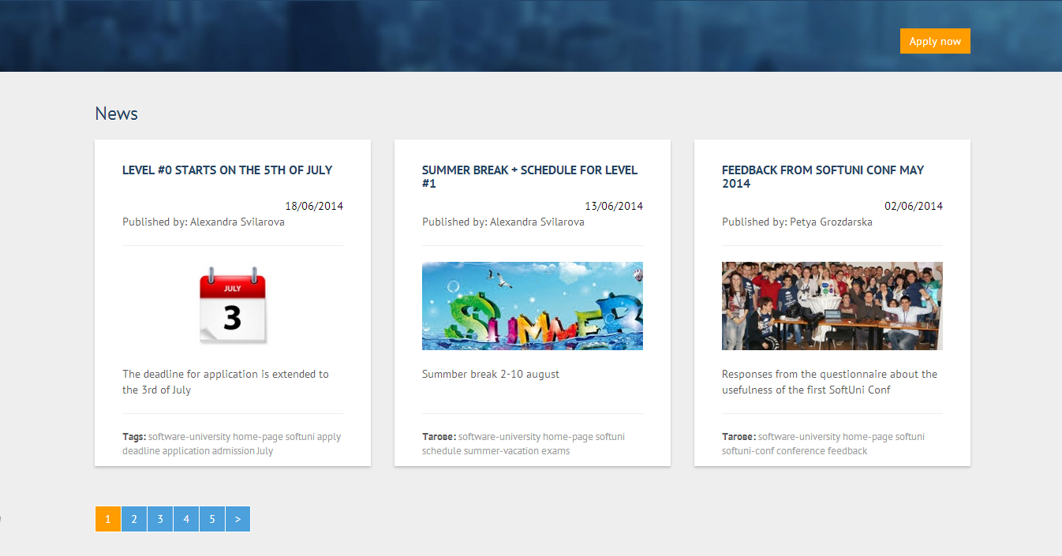

<!DOCTYPE html>

<html>

<head>

<link rel="stylesheet" href="reset.css"/>

<link href="style.css" rel="stylesheet" />

<title>Softuni News</title>

<meta charset = "utf-8" />

</head>

<body>

<div id="wrapper">

<header>News</header>

<section>

<article>

<header>

<a href="http://softuni.bg" title="level 0">level #0 starts on the 5th of july</a>

<time datetime="date">18/06/2014</time>

<address>Published by: Alexandra Svilarova</address>

</header>

<a href="http://softuni.bg" title="level date">

<figure>

<img src="resources/calendar.jpg" alt="3 July"/>

<figcaption>The deadline for application is extended to the 3rd of July</figcaption>

</figure>

</a>

<footer>

<span class="bold">Tags:</span>

software-university home-page softuni apply deadline application admission July

</footer>

</article>

<article>

<header>

<a href="http://softuni.bg">summer break + schedule for level #1</a>

<time datetime="date">13/06/2014</time>

<address>Published by: Alexandra Svilarova</address>

</header>

<a href="http://softuni.bg">

<figure>

<img src="resources/summer.jpg" alt="vacation"/>

<figcaption>Summer break 2-10 august</figcaption>

</figure>

</a>

<footer>

<span class="bold">Тагове:</span>

software-university home-page softuni schedule summer-vacation exams

</footer>

</article>

<article>

<header>

<a href="http://softuni.bg">feedback from softuni conf may 2014</a>

<time datetime="date">02/06/2014</time>

<address>Published by: Petya Grozdanska</address>

</header>

<a href="http://softuni.bg">

<figure>

<img src="resources/softuni-conf.jpg"/>

<figcaption>Responses from the questionaire about the usefulness of the first Softuni Conf</figcaption>

</figure>

</a>

<footer>

<span class="bold">Тагове:</span>

software-university home-page softuni softuni conf conference feedback

</footer>

</article>

</section>

<nav>

<ul>

<li><a href = "#">1</a></li>

<li><a href = "#">2</a></li>

<li><a href = "#">3</a></li>

<li><a href = "#">4</a></li>

<li><a href = "#">5</a></li>

<li><a href = "#">&gt;</a></li>

</ul>

</nav>

</div>

</body>

</html>

## Pretty Website

Create a HTML page like the image below.Use **external CSS file** for the styles. You are given all the images. The font of the page is "Arial".

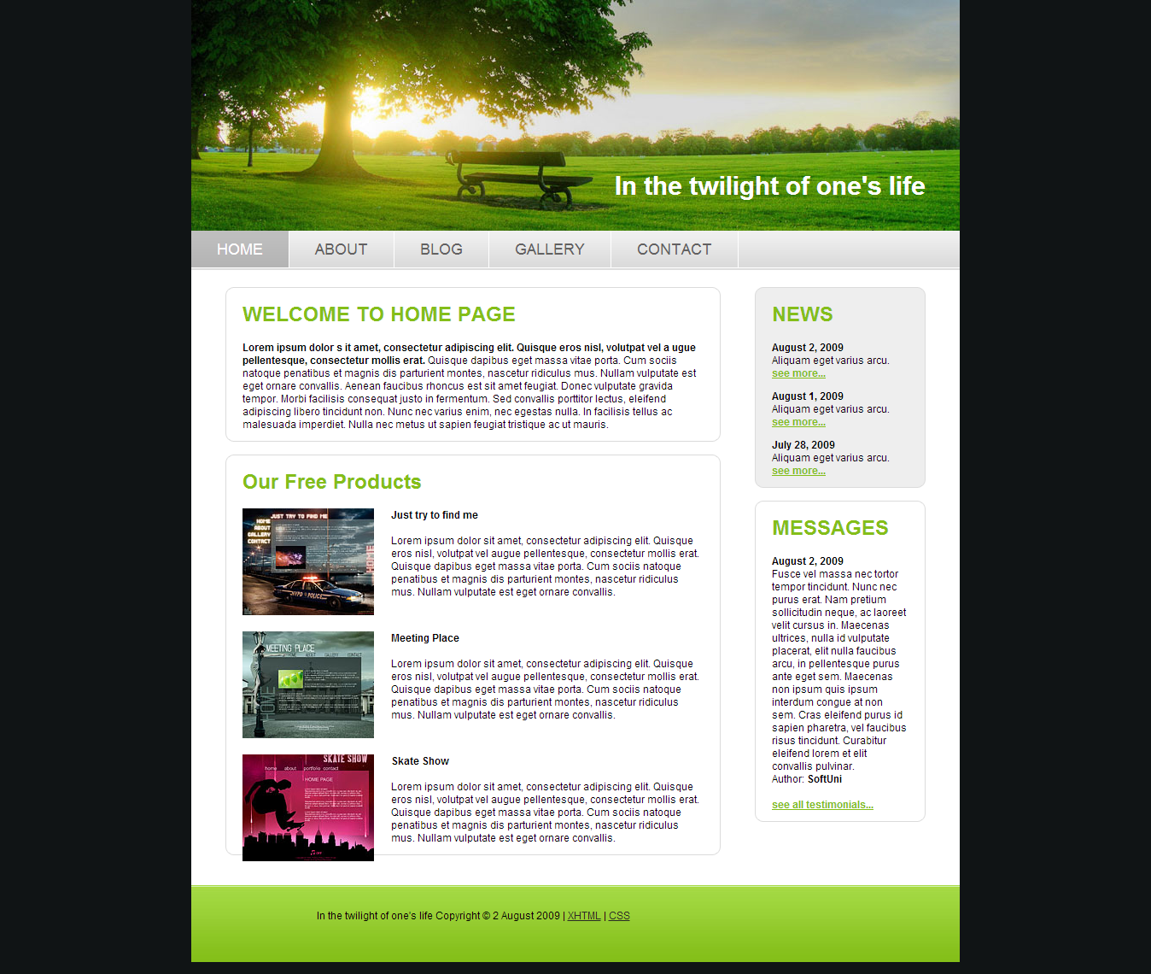

## * Pretty Responsive Website

Make **responsive** the HTML page from the previous problem. Optimize it for tablets and smartphones.